שיעורי בית יסודות – מספרים שלמים וראשוניים (ולולאות FOR מקוננות) אופיר הופמן י3

**תרגיל 1.א.**

// Get number from user

Console.WriteLine("Enter a number: ");

int num = int.Parse(Console.ReadLine());

// Repeat on every number from 1 to the input number

for (int x = 1; x <= num; x++)

{

// Sum of dividers

int sum = 0;

// Repeat on every sub-number

for (int i = 1; i < x; i++)

{

// Check if number divides by sub-number

if (x % i == 0)

{

sum += i;

}

}

// Check if sum of dividers equals to the number

if (sum == x)

{

Console.WriteLine(x);

}

**תרגיל 1.ב.**

// Get a number from user

Console.WriteLine("Enter a number:");

int num = int.Parse(Console.ReadLine());

// Prime numbers counter

int prime = 0;

// Repeat as long as there are no more than 5 prime numbers

for (int x = 1; prime != 5 && x < num; x++)

{

int sum = 0;

for (int i = 1; i < x; i++)

{

if (x % i == 0)

{

sum += i;

}

}

if (sum == x)

{

Console.WriteLine(x);

prime++;

}

**תרגיל 2**

// get number from user

Console.WriteLine("Enter a number:");

int num = int.Parse(Console.ReadLine());

// repeat on each number from 2 to input num

for (int x = 2; x <= num; x++)

{

bool is_prime = true; // stoping condition

// repeat on every sub-number as long as it has no dividers

for (int i = 2; i < x && is_prime == true; i++)

{

if (x % i == 0)

{

is_prime = false;

}

}

if (is_prime == true)

{

Console.WriteLine(x);

}

}

**קינון**

**תרגיל א**

int num = 1;

for (int x = 1; x <= 4; x++)

{

for (int i = num; i <= num+4; i++)

{

Console.Write(i);

}

num++;

Console.WriteLine();

}

**תרגיל ב**

int num = 1;

for (int i = 1; i <= 5; i++)

{

for (int x = 1; x <= num; x++)

{

Console.Write("*");

}

num++;

Console.WriteLine();

}

**תרגיל ג**

int num = 1;

for (int i = 1; i <= 5; i++)

{

for (int x = 1; x <= num; x++)

{

Console.Write(num);

}

num++;

Console.WriteLine();

}

**תרגיל ד**

int num = 1;

for (int i = 1; i <= 5; i++)

{

for (int x = 1; x <= num; x++)

{

Console.Write("*");

}

num++;

Console.WriteLine();

}

**תרגיל ה**

int num = 1;

for (int i = 1; i <= 5; i++)

{

for (int x = 1; x <= num; x++)

{

Console.Write(num);

}

num++;

Console.WriteLine();

}

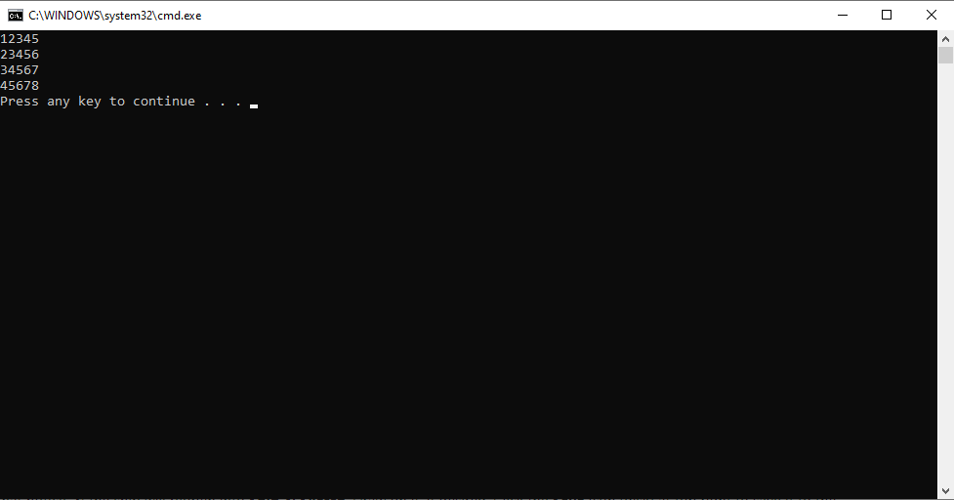

**תרגיל ו**

int num = 1;

for (int i = 1; i <= 5; i++)

{

for (int x = 1; x <= num; x++)

{

Console.Write("*");

}

num++;

Console.WriteLine();

}

**תרגיל ו**

int num = 1;

for (int i = 1; i <= 5; i++)

{

for (int x = 1; x <= num; x++)

{

Console.Write("*");

}

num++;

Console.WriteLine();

}

**תרגיל ז**

int num = 1;

for (int i = 1; i <= 5; i++)

{

for (int x = 1; x <= num; x++)

{

Console.Write(num);

}

num++;

Console.WriteLine();

}

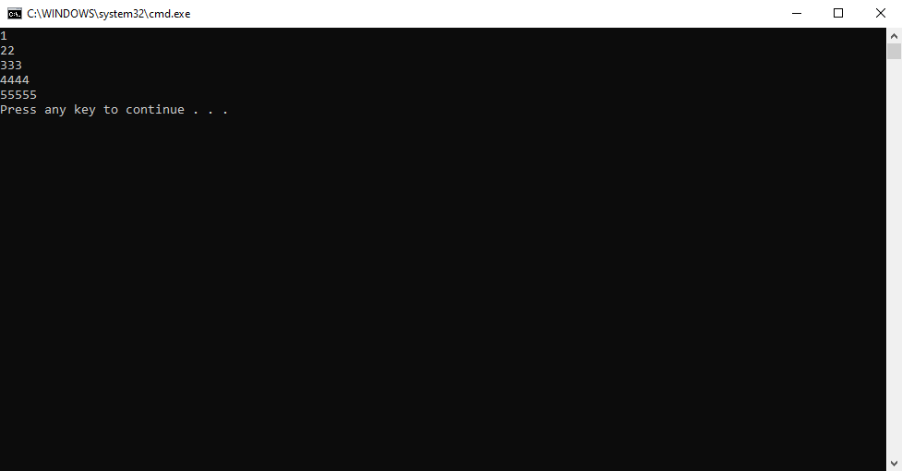

**תרגיל ח**

int first = 1;

int last = 1;

for (int i = 1; i <= 5; i++)

{

for (int x = first; x <= last; x++)

{

Console.Write(x);

}

first++;

last += 2;

Console.WriteLine();

}

**תרגיל ט**

int last = 5;

for (int i = 1; i <= 5; i++)

{

for (int x = 5; x >= last; x--)

{

Console.Write(x);

}

last--;

Console.WriteLine();

}

**תרגיל י**

int spaces = 4;

int stars = 1;

for (int i = 1; i <= 5; i++)

{

for (int x = 1; x <= spaces; x++)

{

Console.Write(" ");

}

for (int y = 1; y <= stars; y++)

{

Console.Write("*");

}

spaces--;

stars++;

Console.WriteLine();

}

**תרגיל יא**

int spaces = 4;

int last = 1;

for (int i = 1; i <= 5; i++)

{

for (int x = 1; x <= spaces; x++)

{

Console.Write(" ");

}

for (int y = 1; y <= last; y++)

{

Console.Write(y);

}

spaces--;

last++;

Console.WriteLine();

}

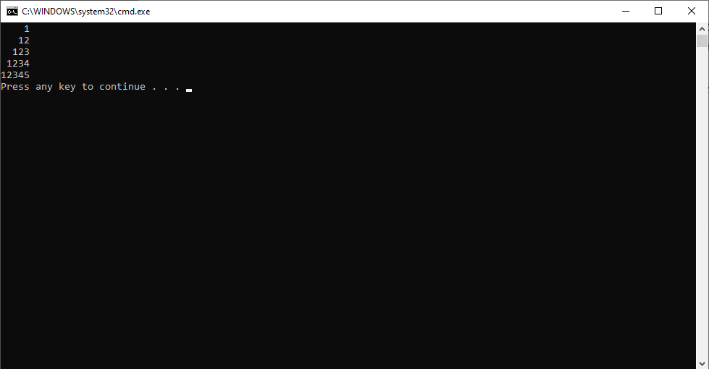

**תרגיל יב**

int num = 5;

for (int i = 1; i <= 5; i++)

{

for (int x = 1; x<= num; x++)

{

Console.Write("*");

}

num--;

Console.WriteLine();

}

**תרגיל יג**

int last = 1;

for (int i = 1; i <= 5; i++)

{

for (int x = 5; x >= last; x--)

{

Console.Write(x);

}

last++;

Console.WriteLine();

}